Assignments

1. Create a directory ‘project_dir’ & cd to ‘project_dir’.

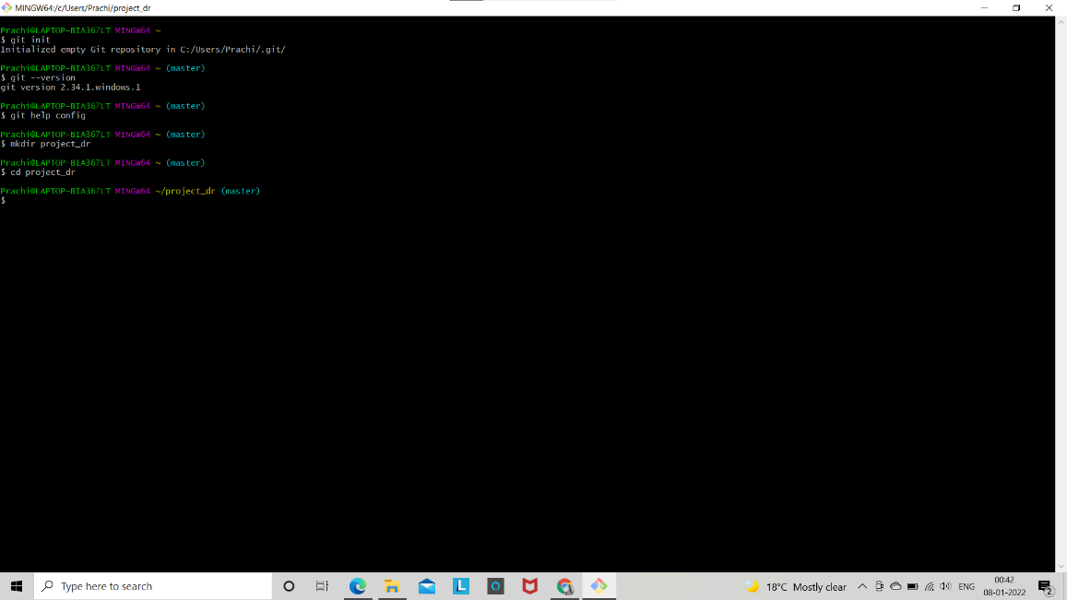

1. Initialize git version database. (git init)

1. Create a new file index.html.

4. Check the git status. You should find index.html as untracked file.

1. Stage the index.html file

1. Commit index.html

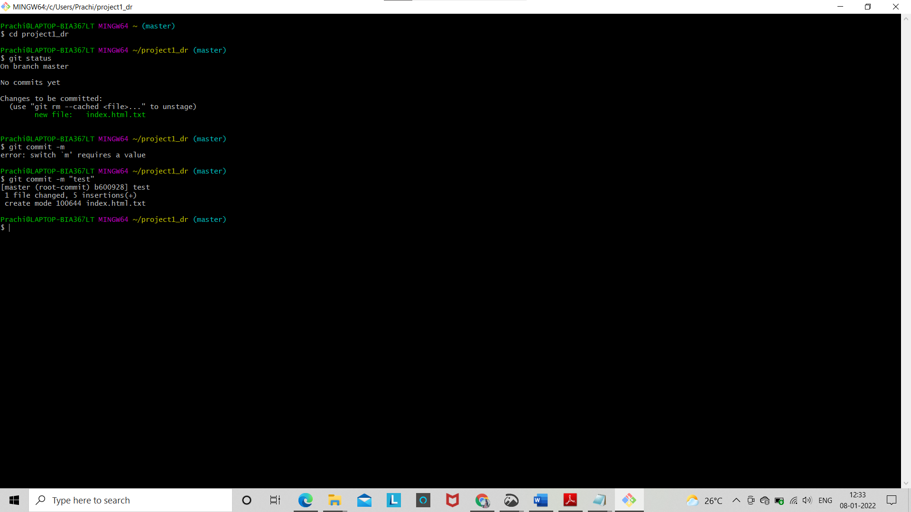

1. Make few changes in index.html & create a new file info.txt file.

8. Check git status. You should find index.html & info.txt as untracked files.

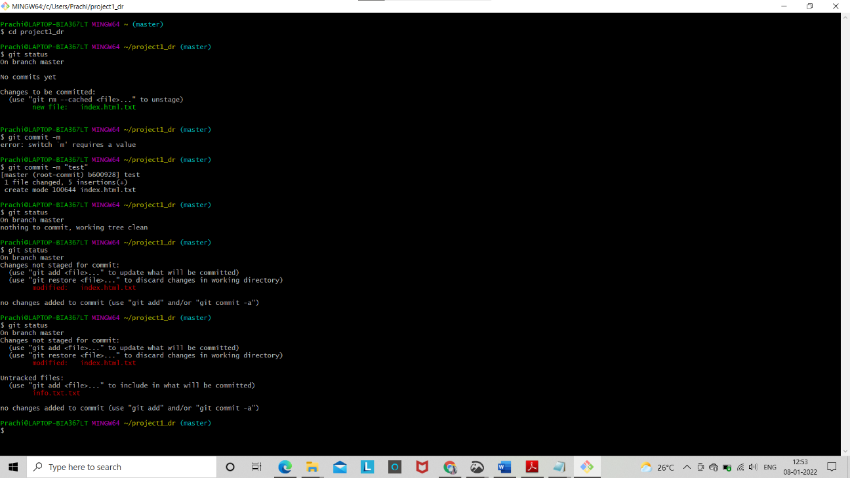

1. Configure GIT to ignore all txt files.

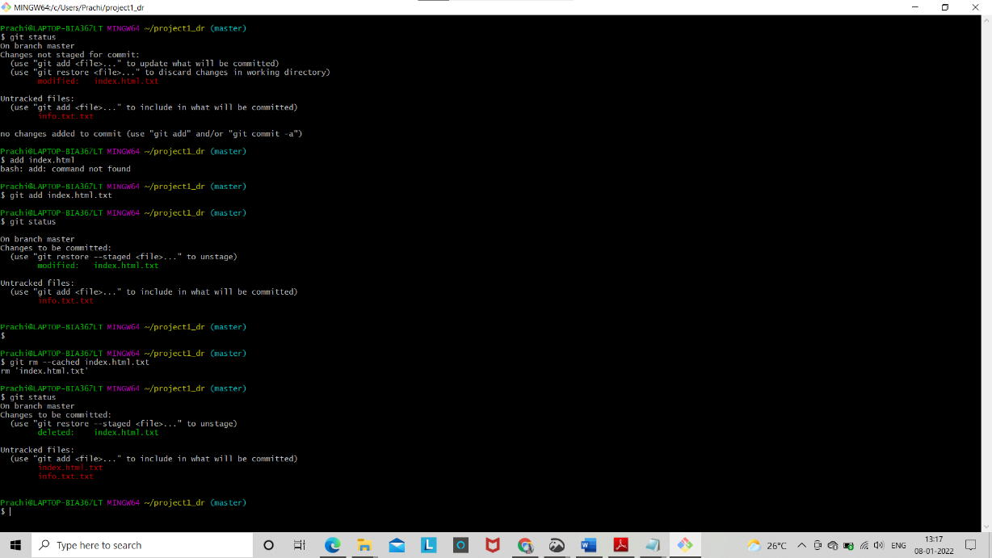

9. Configure GIT to ignore all txt files.

10. Again check the git status. You should find only index.html as untracked file.

11. State & commit index.html

12. Log all your comments so far.

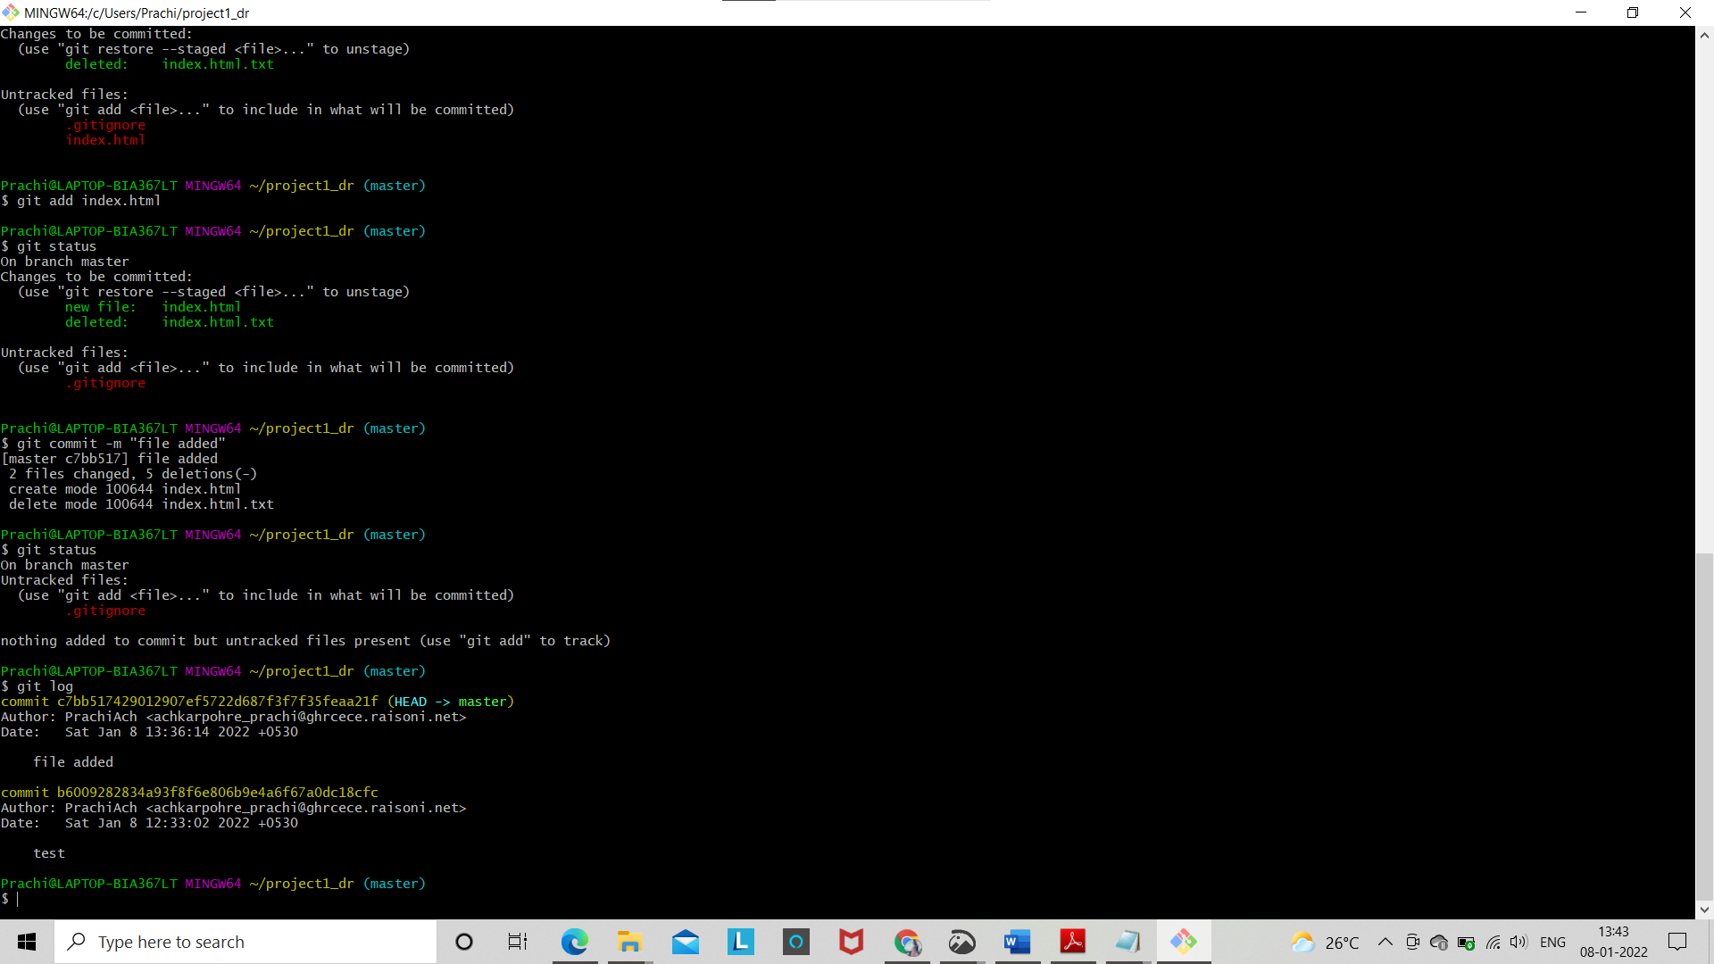

13. Make some changes in index.html.

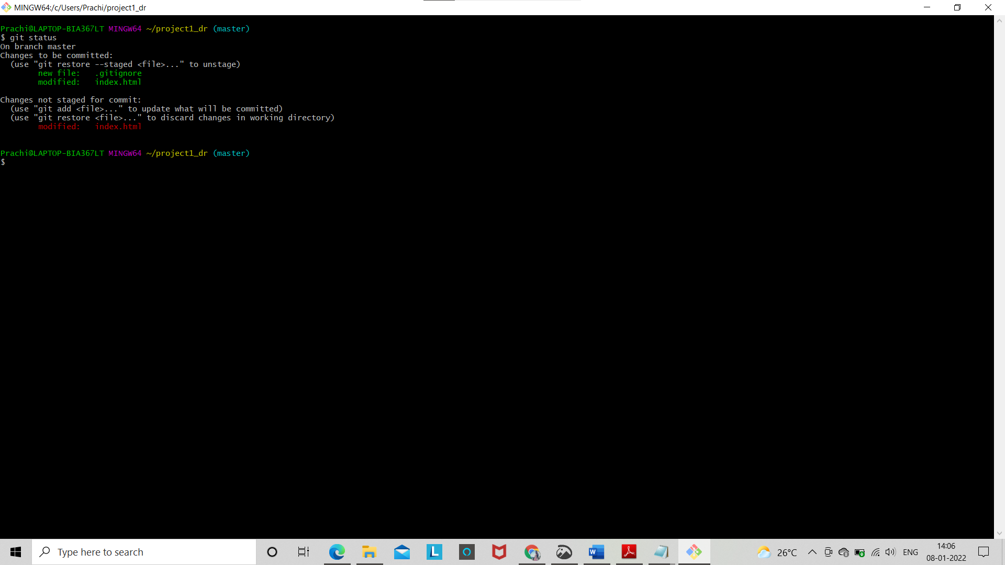

14. Revert the change made in the previous step using git command

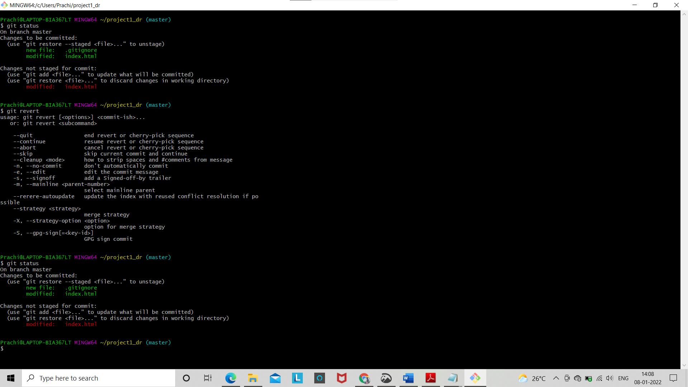

15. Again change index.html.

16. Stage index.html

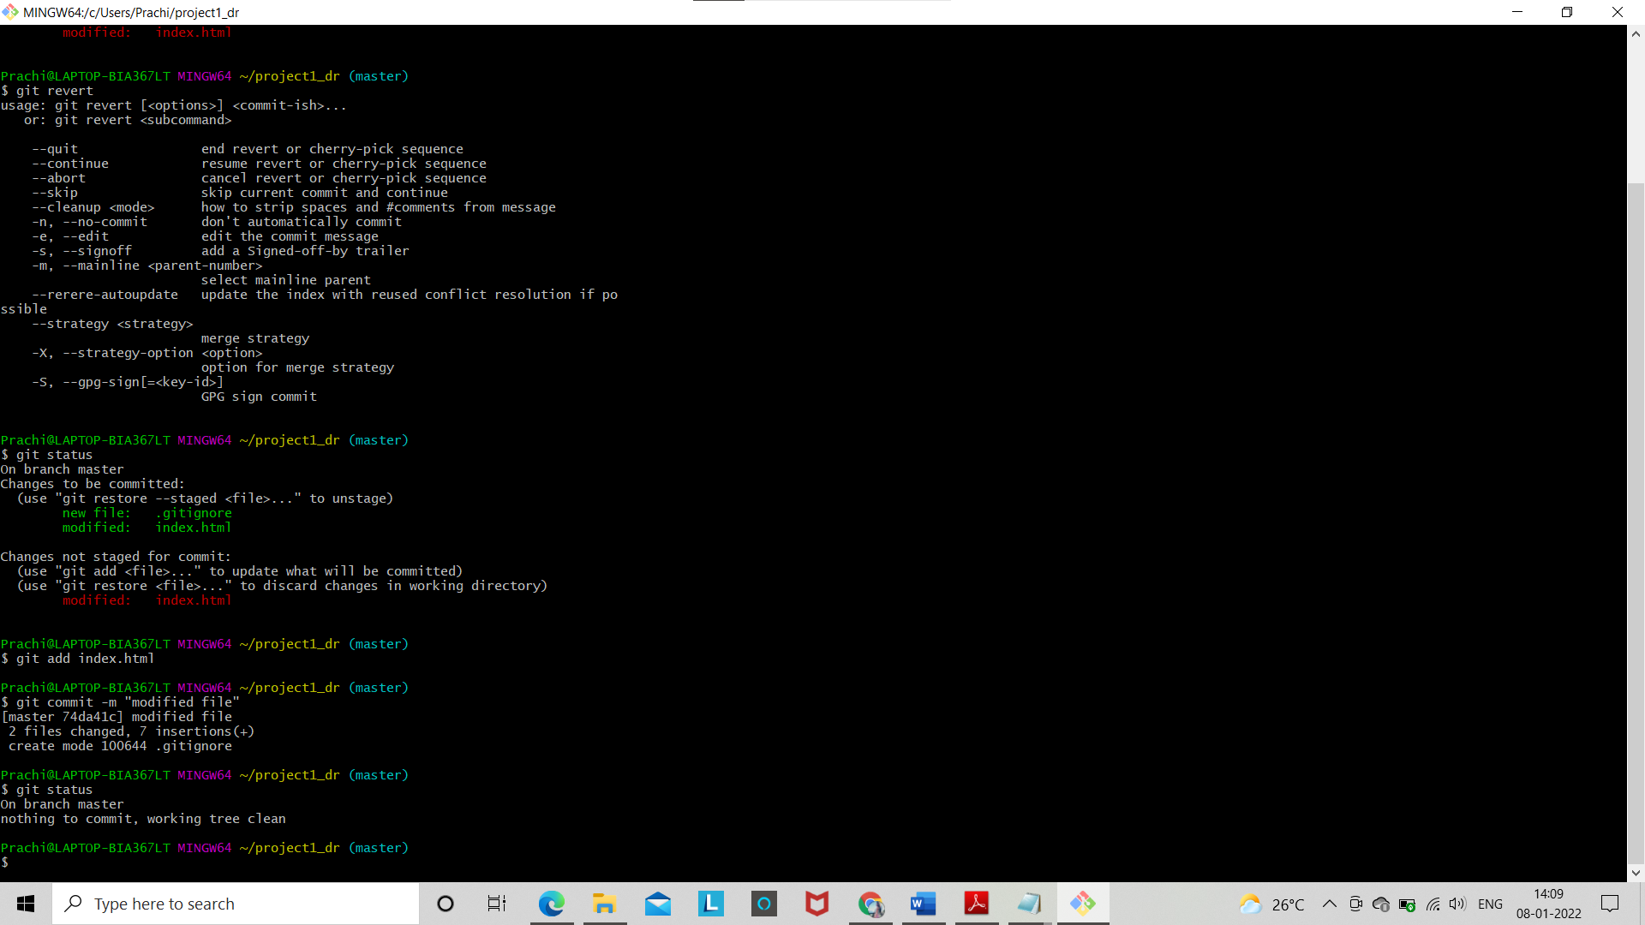

18. Rename ‘add’ command to ‘my-add’.

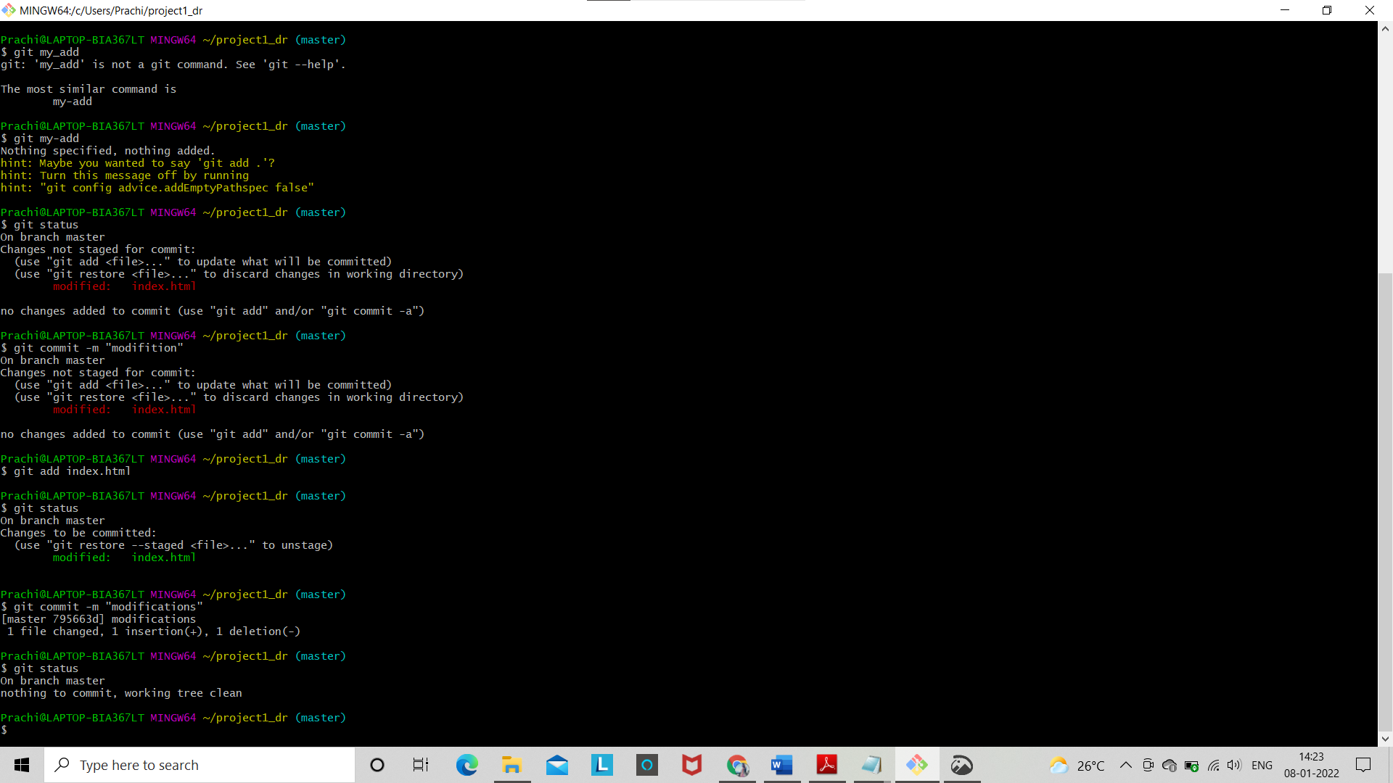19. Check git status and again commit the index.html .

20. Revert the last command.

Section -1 (HTML assignments) - Steps to follow:

21. First take a backup of your assignments & projects. This is required because due to incorrect GIT operation you may lose your files.

22. Create an empty directory ‘Assignments’ & cd to ‘Assignments’.

23. Create a file README.txt inside ‘Assignments’ & write few lines about the contents of ‘Assignments’ folder.

24. Commit README.txt file.

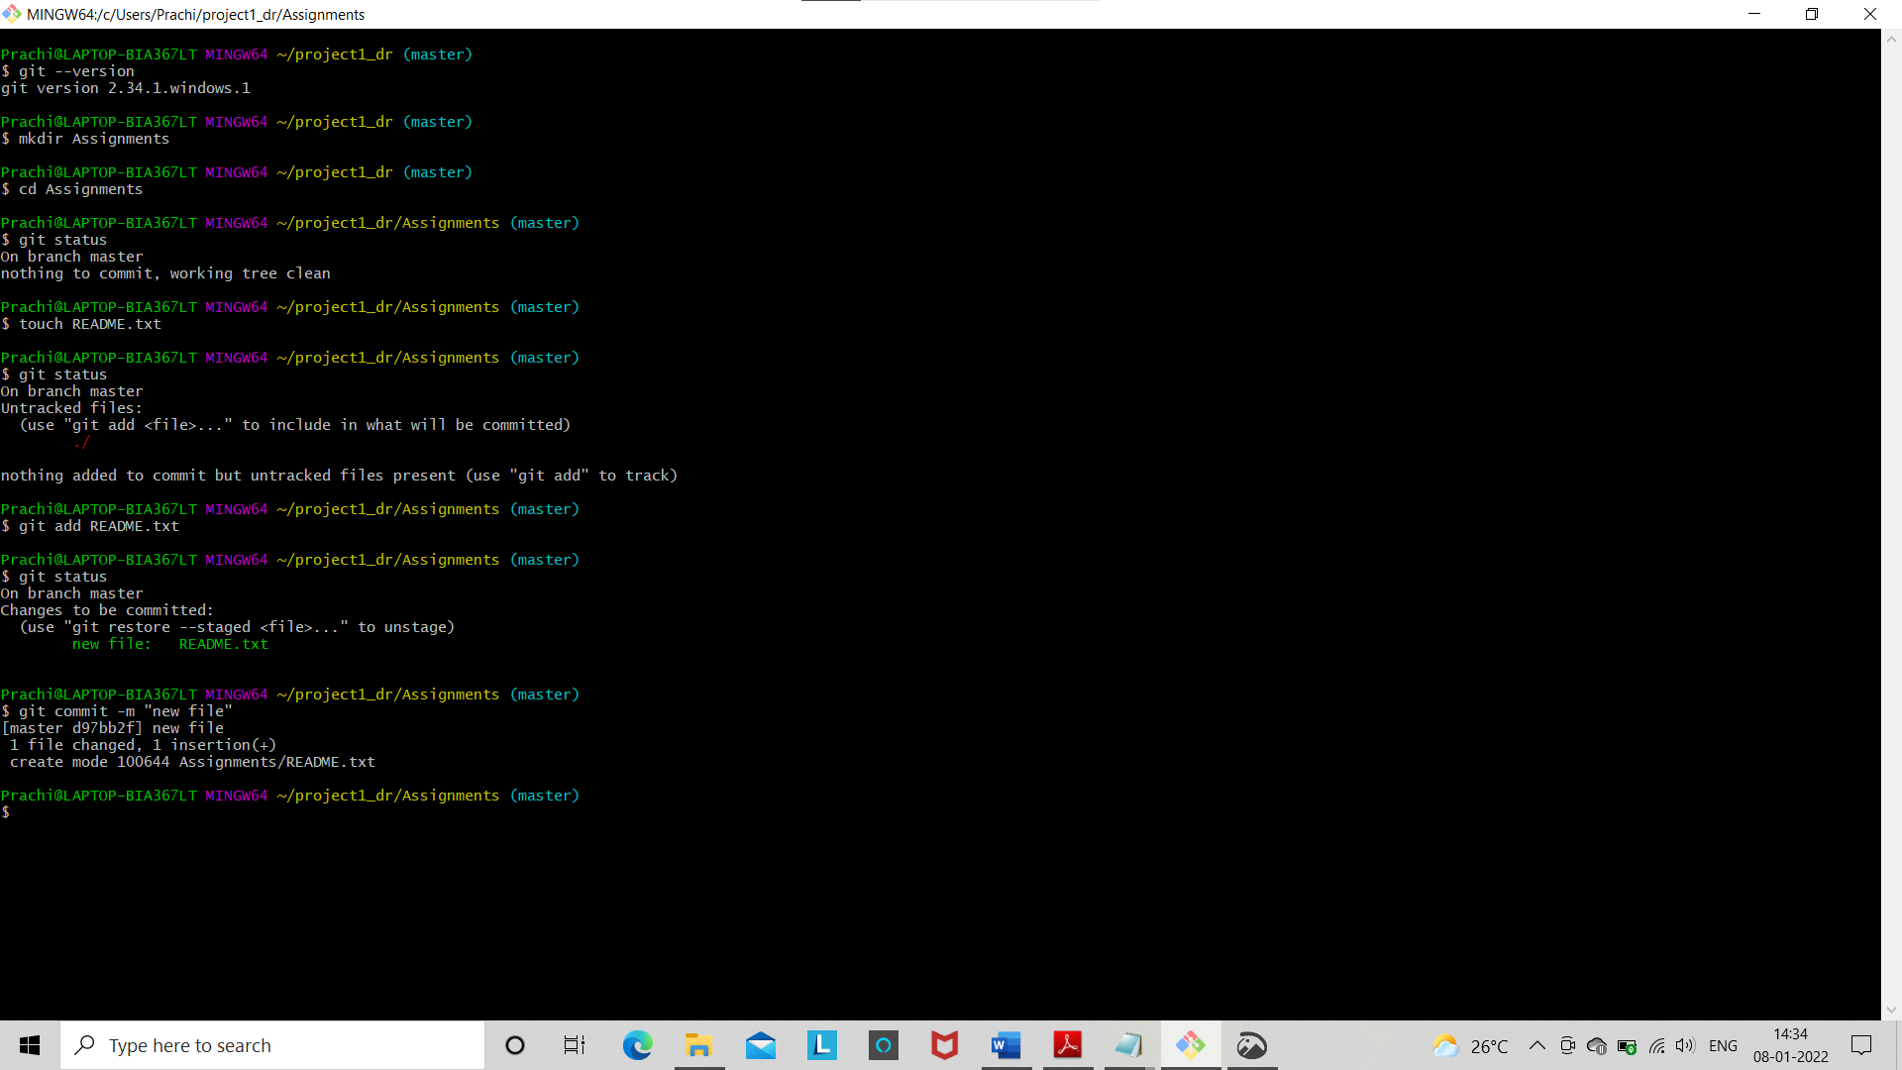

25. Create new branch “html-assignments”

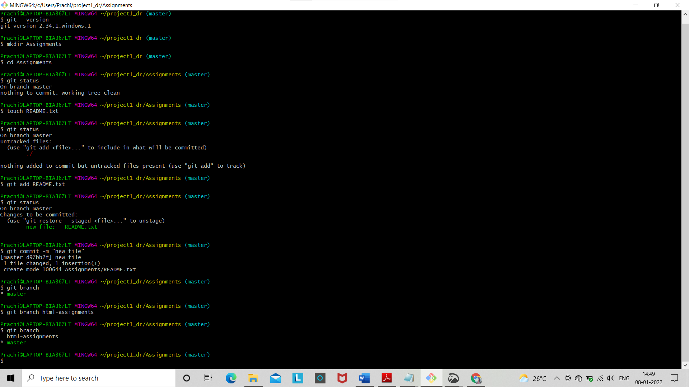

26. Switch to ‘html-assignments’ branch.

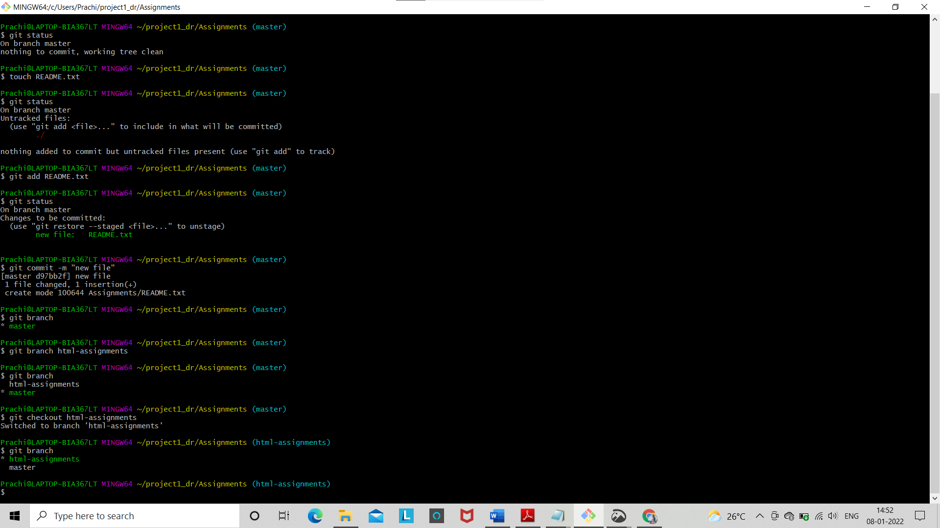

27. Copy all HTML assignments inside ‘Assignments’ folder.

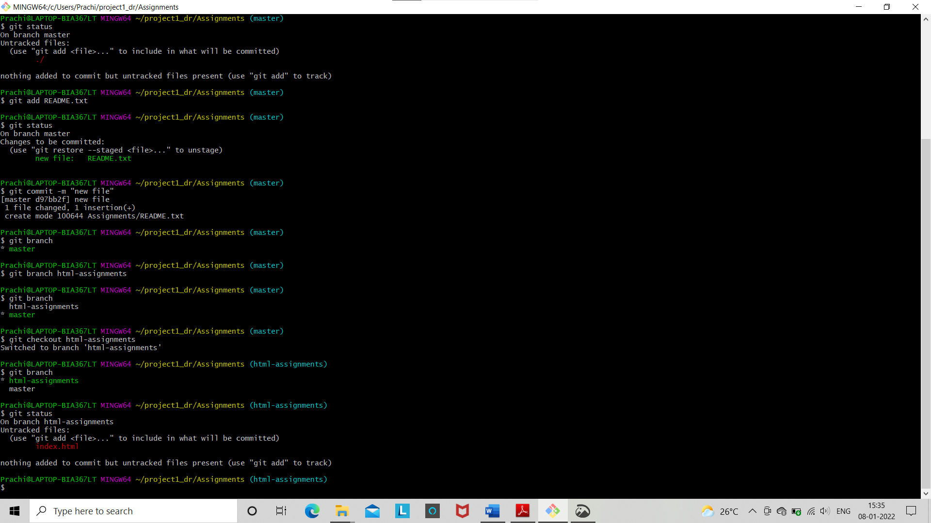

28. Commit HTML assignments into ‘html-assignments’ branch.

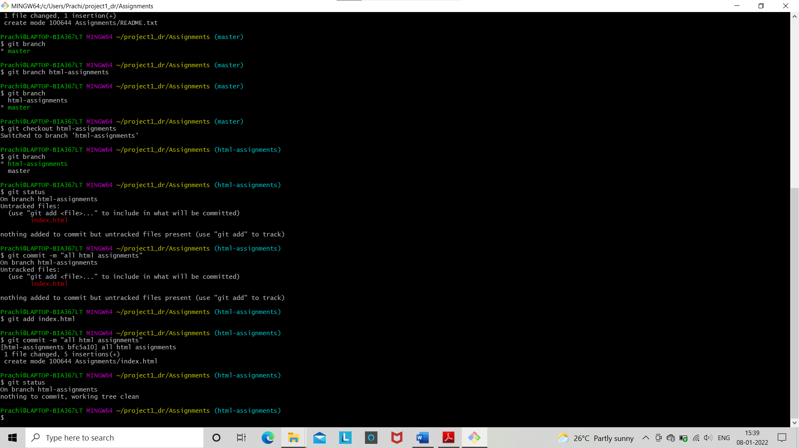

29. Make minor changes into few files belonging to ‘html-assignments’ branch.

30. Commit those changed files.

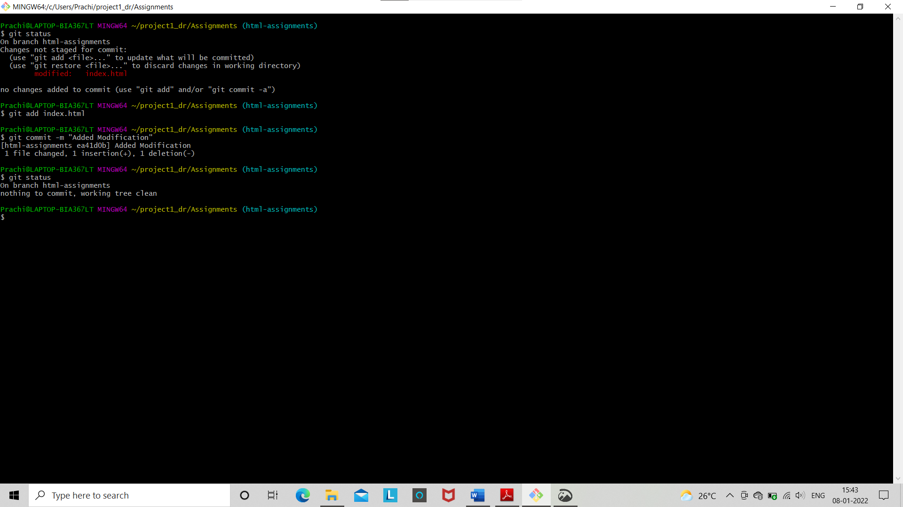

31. Switch to master branch.

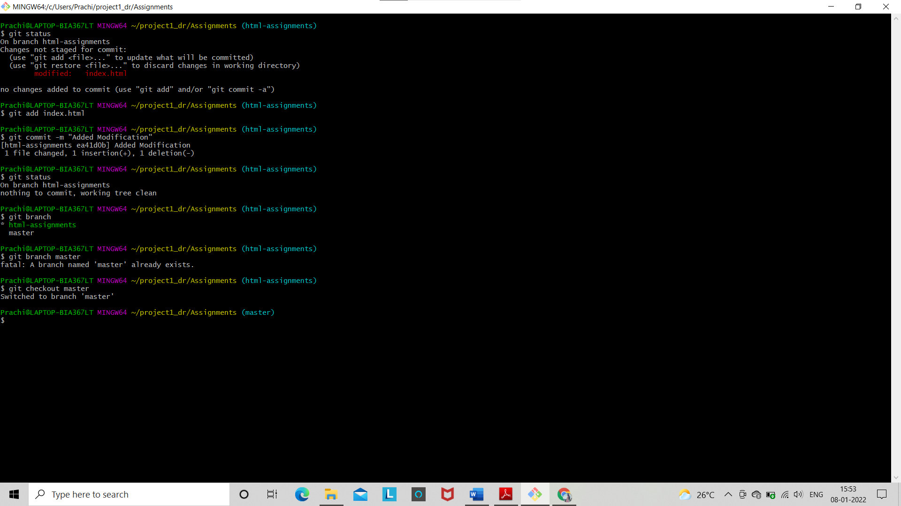

32. Make minor changes into README.txt file & commit those changes into master.

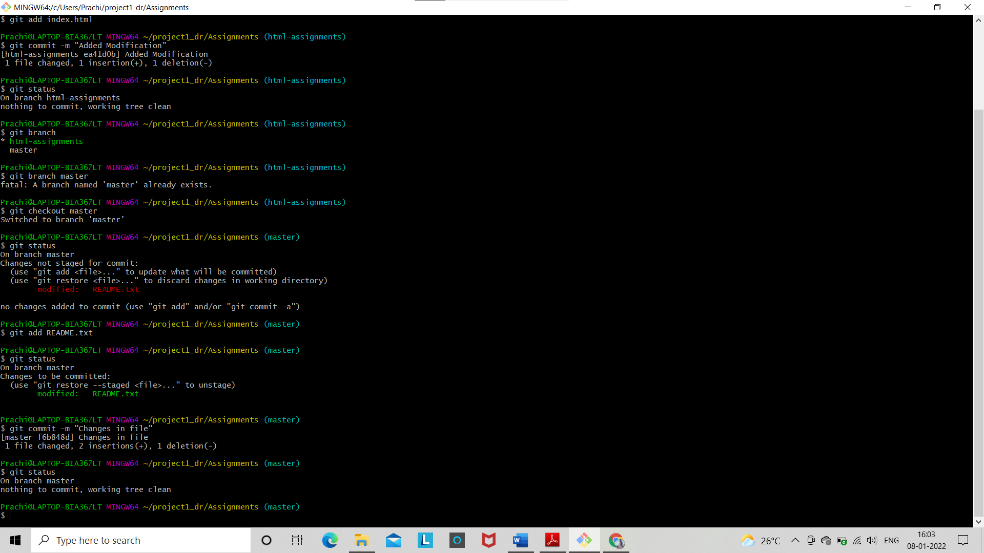

34. Make minor changes into few files belonging to ‘html-assignments’ branch.

35. Commit those changes.

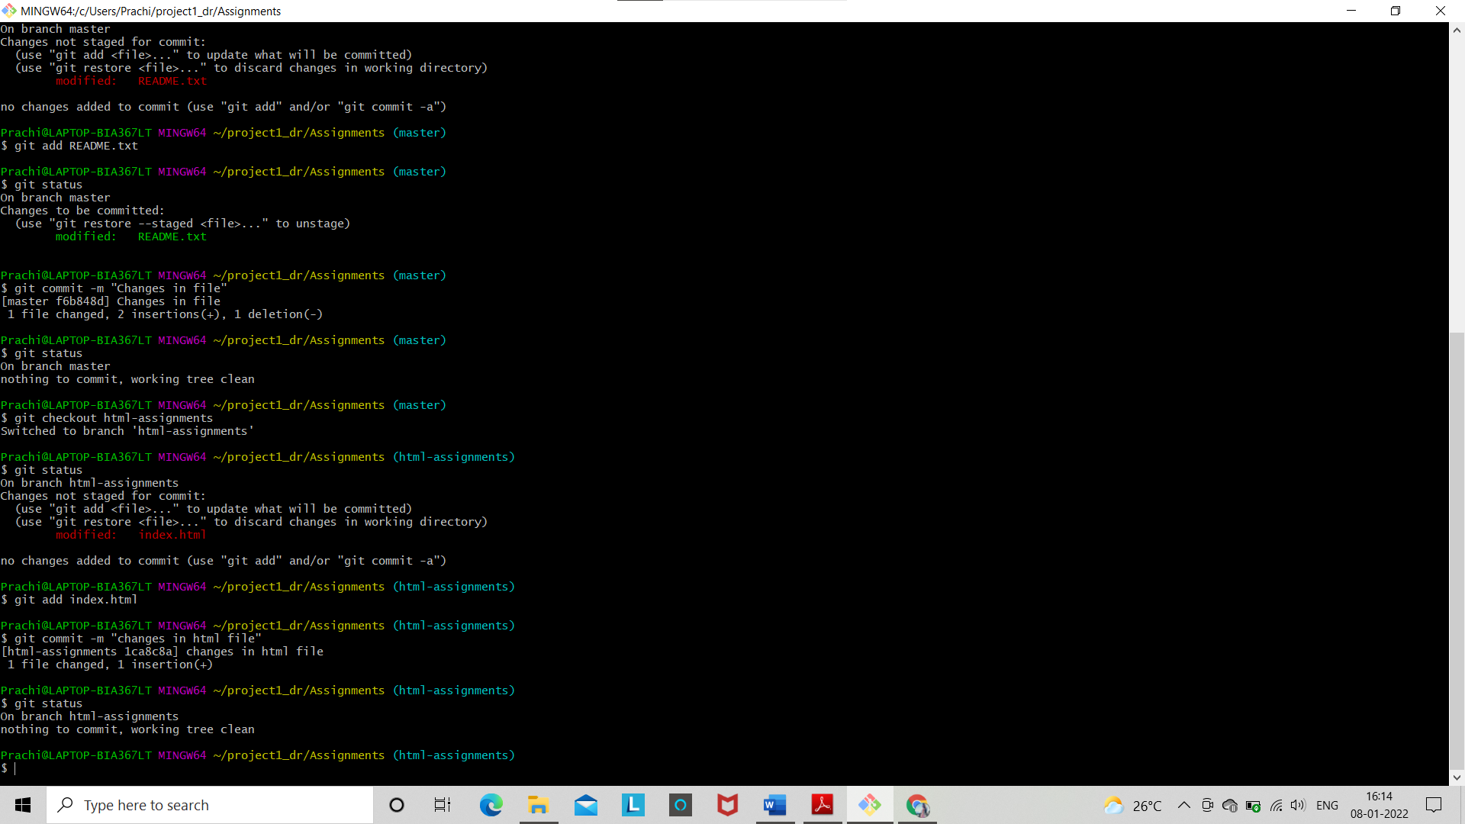

36. Switch to master.

37. Merge ‘html-assignments’ branch into master. Confirm all html assignments are shown in master.

38. Finally delete the ‘html-assignments’ branch.

